Joseph Silva Jr.

09/26/2021

SNHU

DAT: 4-1 Exercise 3

**a) Learning Library 05 – Correlation**

* **A scatterplot matrix and pairwise correlation analysis of [Duration, Speed, Height, Drop, Length] from Roller Coasters data.**

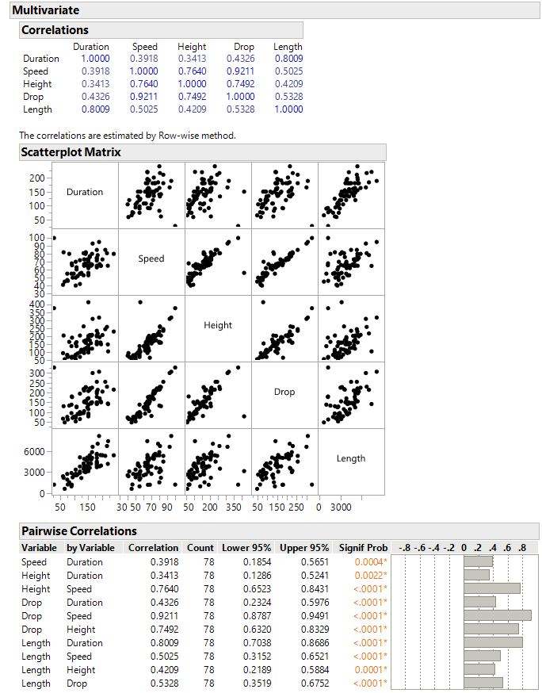

**b) Learning Library 07 – Principal Components Analysis**

* **Summary Plots and Eigenvectors analysis of [Duration, Speed, Height, Drop, Length] from Roller Coasters data.**

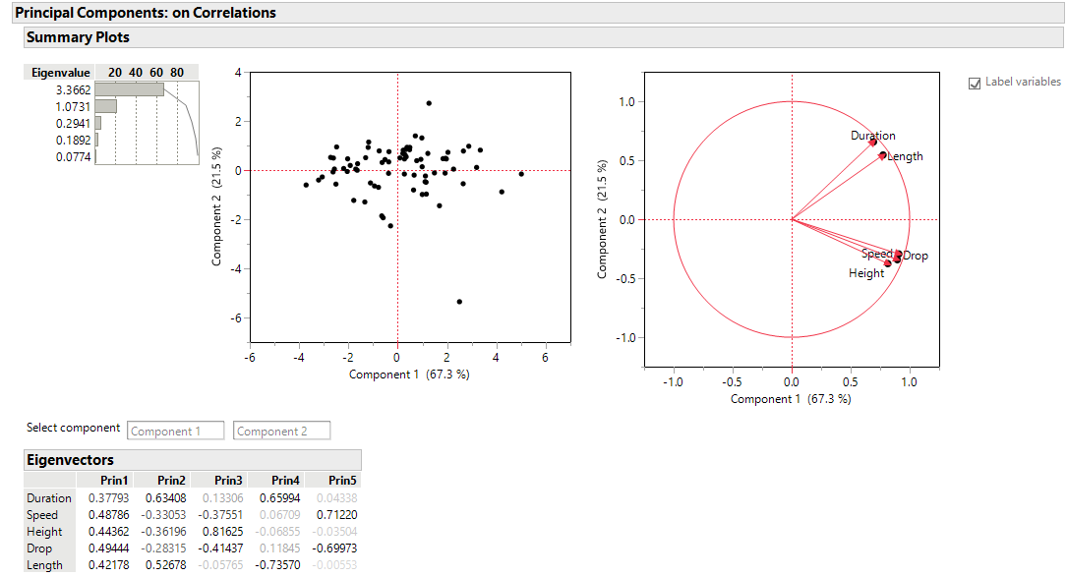

**c) An explanation of the relationship between these variables and how the analyses informed you of those relationships.**

The variables in the roller-coaster data have relationships between each other. These variables are duration, speed, height, drop, and length. I can see the variables duration and length have a relationship to each other. The next group of variables speed, height, and drop also have a relationship between each other. We can see these relationships by using the summary plot and the correlations numbers. For example, duration and length correlation numbers are 0.8009 while duration with the other variables is lower than 0.45. The variables correlation for speed, height, and drop are all above 0.73 while any of these variables’ correlation with duration or length are below 0.55. Correlation relationship means the degree level a variable corresponds with another variable. Basically, the longer the roller coaster in length means the longer the duration the roller coaster takes to end. It also shows the longer the roller coaster is in length, the slower the roller coaster is in speed if we are going by the data.